**Image Processing Using SCIPY :**

**(1) from scipy import misc**

**img = misc.imread("C:/Users/abc/Desktop/image/test_image.jpg")**

**print(type(img))**

**→ <class ‘numpy.ndarray’>**

**NOTE: misc.imread has no longer supported in python**

**→ So that now we use skimage library for read the image!!!**

**(2) from skimage import io**

**img = io.imread("C:/Users/abc/Desktop/image/test_image.jpg")**

**print(type(img))**

**→ <class ‘numpy.ndarray’>**

**(3) from skimage import io**

**img = io.imread("C:/Users/abc/Desktop/image/test_image.jpg")**

**print(type(img))**

**print(img.dtype,img.shape)**

**→ <class 'numpy.ndarray'>**

**uint8 (340, 546, 3)**

**(4) from skimage import io**

**img=io.imread("C:/Users/abc/Desktop/image/test_image.jpg",as_gray=True)**

**print(type(img))**

**print(img.dtype,img.shape)**

**print(img)**

**→ <class 'numpy.ndarray'>**

**float64 (340, 546)**

**[[0.05045961 0.06165098 0.07144353 ... 0.05574157 0.05265333 0.04873176]**

**[0.05494667 0.06165098 0.06360039 ... 0.05182 0.05493098 0.05493098]**

**[0.0510251 0.04988627 0.04791412 ... 0.05182 0.05834745 0.05834745]**

**...**

**[0.01568627 0.01568627 0.01568627 ... 0.01568627 0.01568627 0.01568627]**

**[0.01568627 0.01568627 0.01568627 ... 0.01568627 0.01568627 0.01568627]**

**[0.01568627 0.01568627 0.01568627 ... 0.01568627 0.01568627 0.01568627]]**

**(5) from skimage import io , img_as_ubyte**

**img=img_as_ubyte(io.imread("C:/Users/abc/Desktop/image/test_image.jpg",as_gray=True))**

**print(img.dtype,img.shape)**

**→ uint8 (340, 546)**

**(6) from skimage import io , img_as_ubyte**

**img=img_as_ubyte(io.imread("C:/Users/abc/Desktop/image/test_image.jpg"))**

**print(img[0,0])**

**→ [10 13 20]**

**(7) from skimage import io , img_as_ubyte**

**img=img_as_ubyte(io.imread("C:/Users/abc/Desktop/image/test_image.jpg",as_gray=True))**

**print(img[0,0])**

**→ 13**

**(8) from skimage import io , img_as_ubyte**

**img=img_as_ubyte(io.imread("C:/Users/abc/Desktop/image/test_image.jpg",as_gray=True))**

**print(img[10:15,20:25])**

**→ [[15 16 14 12 16]**

**[12 15 17 17 14]**

**[14 15 18 18 13]**

**[19 17 14 14 15]**

**[21 16 13 14 20]]**

**(9) from skimage import io , img_as_ubyte**

**img=img_as_ubyte(io.imread("C:/Users/abc/Desktop/image/test_image.jpg",as_gray=True))**

**mean_grey = img.mean()**

**max_value = img.max()**

**min_value = img.min()**

**print("Min ,Max and Mean are :",min_value,max_value,mean_grey)**

**→ Min ,Max and Mean are : 0 255 41.0579885800474**

**(10) from skimage import io,img_as_ubyte**

**from scipy import ndimage**

**import numpy as np**

**from matplotlib import pyplot as plt**

**img=img_as_ubyte(io.imread("C:/Users/abc/Desktop/image/test_image.jpg",as_gray=True))**

**flippedLR = np.fliplr(img)**

**flippedUD = np.flipud(img)**

**plt.subplot(2,1,1)**

**plt.imshow(img)**

**plt.subplot(2,2,3)**

**plt.imshow(flippedLR)**

**plt.subplot(2,2,4)**

**plt.imshow(flippedUD)**

**→ This is gray image: → This is original image :**

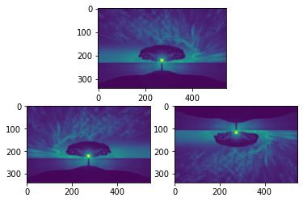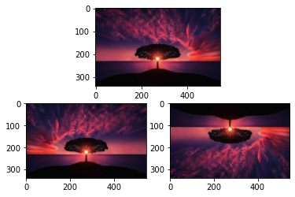

**(11)** **Convert original image into different colormap using matplotlib library :**

**from skimage import io,img_as_ubyte**

**from scipy import ndimage**

**import numpy as np**

**from matplotlib import pyplot as plt**

**img = img_as_ubyte(io.imread("C:/Users/abc/Desktop/image/test_image.jpg",as_gray=True))**

**flippedLR = np.fliplr(img)**

**flippedUD = np.flipud(img)**

**plt.subplot(2,1,1)**

**plt.imshow(img,cmap="Greys")**

**plt.subplot(2,2,3)**

**plt.imshow(flippedLR,cmap = "Blues")**

**plt.subplot(2,2,4)**

**plt.imshow(flippedUD,cmap = "hsv")**

**→ There are different color of images:**

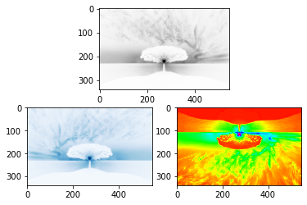

**(12) Rotate the image at 45 degree:**

**from skimage import io,img_as_ubyte**

**from scipy import ndimage**

**import numpy as np**

**from matplotlib import pyplot as plt**

**img=img_as_ubyte(io.imread("C:/Users/abc/Desktop/image/test_image.jpg",as_gray=True))**

**rotated = ndimage.rotate(img,45)**

**plt.imshow(rotated)**

**→**

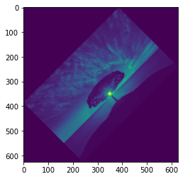

**(13) from skimage import io,img_as_ubyte**

**from scipy import ndimage**

**import numpy as np**

**from matplotlib import pyplot as plt**

**img=img_as_ubyte(io.imread("C:/Users/abc/Desktop/image/test_image.jpg",as_gray=True))**

**rotated = ndimage.rotate(img,45,reshape=False)**

**plt.imshow(rotated)**

**→**

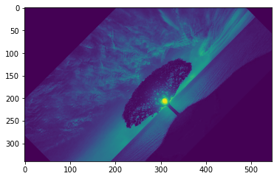

**(14) What is a Uniform filter and Gaussian filter and median filter :**

**from skimage import io,img_as_ubyte**

**from scipy import ndimage**

**import numpy as np**

**from matplotlib import pyplot as plt**

**img=img_as_ubyte(io.imread("C:/Users/abc/Desktop/image/test_image.jpg",as_gray=False))**

**plt.imshow(img)**

**uniform_filtered = ndimage.uniform_filter(img,size=3)**

**plt.imshow(uniform_filtered)**

**gaussian_filtered = ndimage.gaussian_filter(img,sigma=7)**

**plt.imshow(gaussian_filtered)**

**median_filtered = ndimage.median_filter(img,sigma=7)**

**plt.imshow(median_filtered)**

**→ Original Image :**

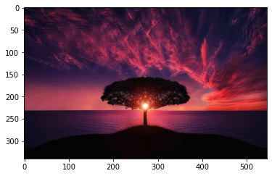

**→ Uniform_Filtered Image:**

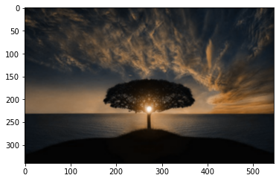

**→ Gaussion_Filtered Image:**

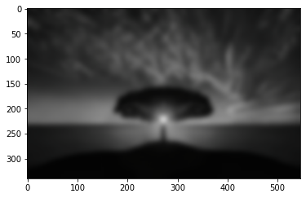

**→ median_filtered Image:**

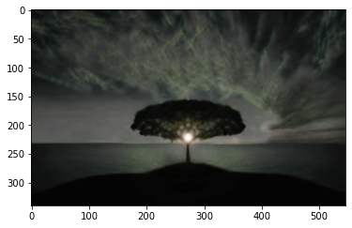

**(15) Sobel filter in image:**

**from skimage import io,img_as_ubyte**

**from scipy import ndimage**

**import numpy as np**

**from matplotlib import pyplot as plt**

**img=img_as_ubyte(io.imread("C:/Users/abc/Desktop/image/test_image.jpg",as_gray=True))**

**plt.imshow(img)**

**sobel_img = ndimage.sobel(img,axis=0)**

**plt.imshow(sobel_img)**

**→ Original grey Image: → Sobel fitered image:**

